

**2,400 Sq. Ft. - Owner Operated C-Store Building**

**Listing ID: 3-1925**

**REAL ESTATE FOR SALE**

**Sosa Foods & Taqueria Deli**

**Location:** 3909 Minnehaha Avenue

Mpls MN 55406

**REAL ESTATE PRICE, TERMS & FINANCIAL SUMMARY:**

|  |  |  |  |
| --- | --- | --- | --- |
| **Asking Real Estate Price:** | $450,000 | **Down Payment:** | $450,000 |
| **Current Rental Income:** | Deli = $3,000/month | **Financing Terms:** | Bank Financing |
| **Potential for Additional C-Store Rental Income:** | C-Store = $1,500/month | **F,F&E:\*** | As Is |
| **Combined Rental Income** | $54,000/Year | **Inventory\*** | N/A  *Not in the Asking Price |

**For Sale is a 2,400 sq.ft C-Store building with 2 businesses. C-Store is operating at breakeven with $1M in sales**

**HIGHLIGHTS:**

* **C-Store operating at breakeven with $1M sales is included in $450,000 price at no additional cost!**
* **Buyer that understands the C-Store business can operate the C-Store to show a profit.**
* **Deli Tenant generates rental income of $3,000 per month, tenant is on a month to month lease.**
* **Fully Equipped Commercial Kitchen - The new owner can generate food revenue or rental income.**
* **Area is served by the Hiawatha Light Rail and is being redeveloped.**
* **New owner may convert entire C-Store building into a full, sit-down restaurant operation.**

**BUSINESS SUMMARY:**

This Convenience Store has been operating since the 1970’s. The customers in the neighborhood buy snacks, drinks, coffee, tobacco products and lottery tickets. The building is equipped with a full commercial Kitchen with exhaust hood, stove, grill, refrigerators, fryer, prep table and prep area. For the last 5 years there has been a Mexican Food tenant renting the kitchen space along with seating for 12 customers within the C-Store. The tenant also operates a Mexican Food Truck from the kitchen. The tenant is on a month-to-month lease paying $3,000 per month. The new owner can extend the lease with the Mexican Food tenant or choose to convert the C-Store space into customer seating area for a restaurant operation.

The entire area between Hiawatha Avenue and Minnehaha Avenue is being redeveloped since the completion of the Hiawatha Light Rail. There are several new high rise apartment communities bringing new customers to the area. The seller is ready to retire and is selling the real estate. He will handle the sale of the inventory separately.

**GENERAL INFORMATION:**

|  |  |  |  |
| --- | --- | --- | --- |
| **Facility Information:** | 2,400 sf – Bldg. size and 9,989 sf - Land Size | **Reason For Sale:** | Retirement |
| **Off Street Parking Spaces** | 16 spaces | **Year Established:** | 1966 |
| **Property Taxes:** | $9,867 | **Employees:** | 1 part time |
| **Hours of Operation:** | 6 AM to 10 PM | **Training:** | Negotiable |
| **Type of Entity:** | S-Corp |  |  |

**CONTACT:**

|  |  |
| --- | --- |
| **Sunbelt Business Advisors**  **1300 Godward Street NE, Suite 6000**  **Minneapolis, MN 55413**  [**www.sunbeltmidwest.com**](http://www.sunbeltmidwest.com) | **Richard Jahnke**  **612-418-4754**  [**rjahnke@sunbeltmidwest.com**](mailto:rjahnke@sunbeltmidwest.com) |

[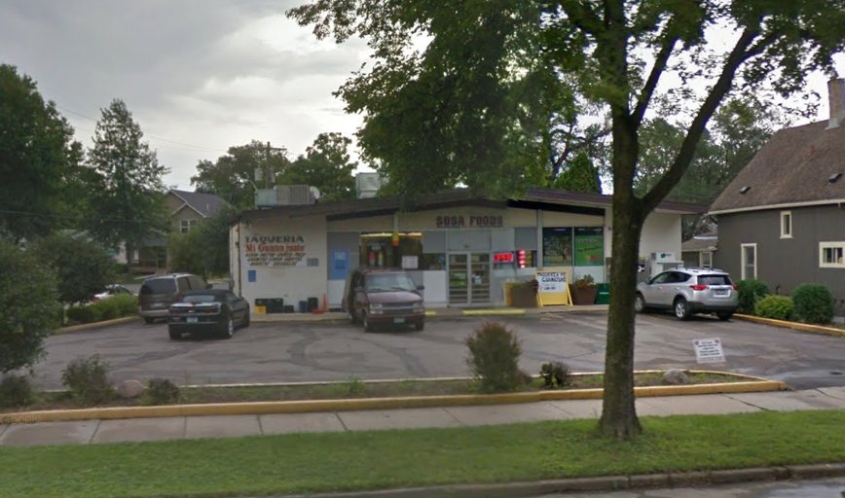](https://s3-media1.fl.yelpcdn.com/bphoto/-Ad3HLgSit6jfkbcWOfuSg/o.jpg)

[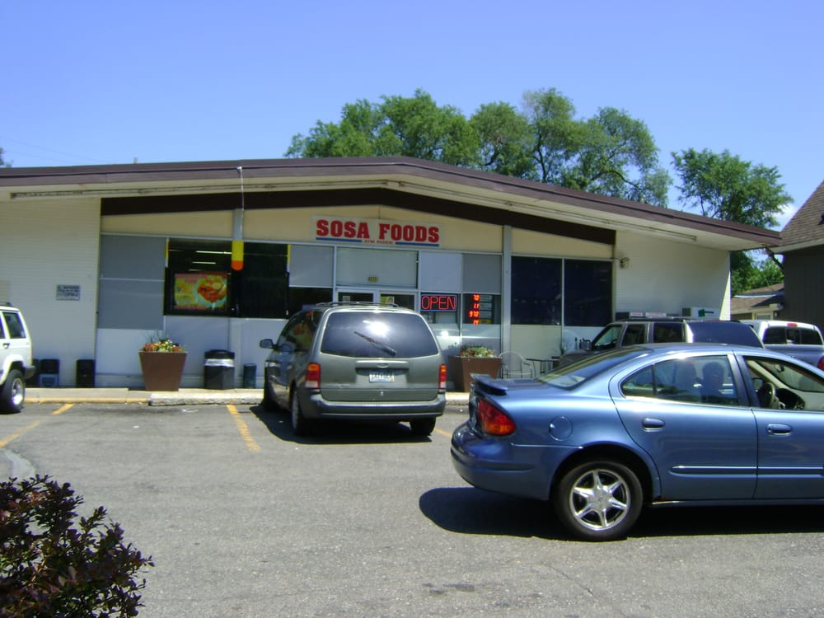](https://s3-media4.fl.yelpcdn.com/bphoto/bSXmN0P4jRDfBfPwzN2YAw/o.jpg)

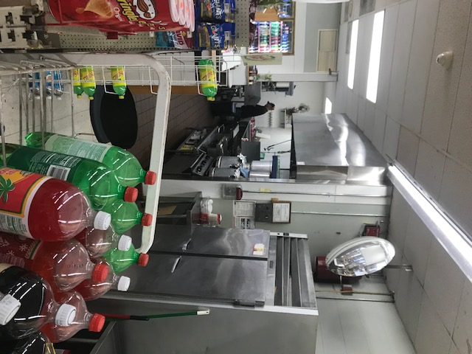

[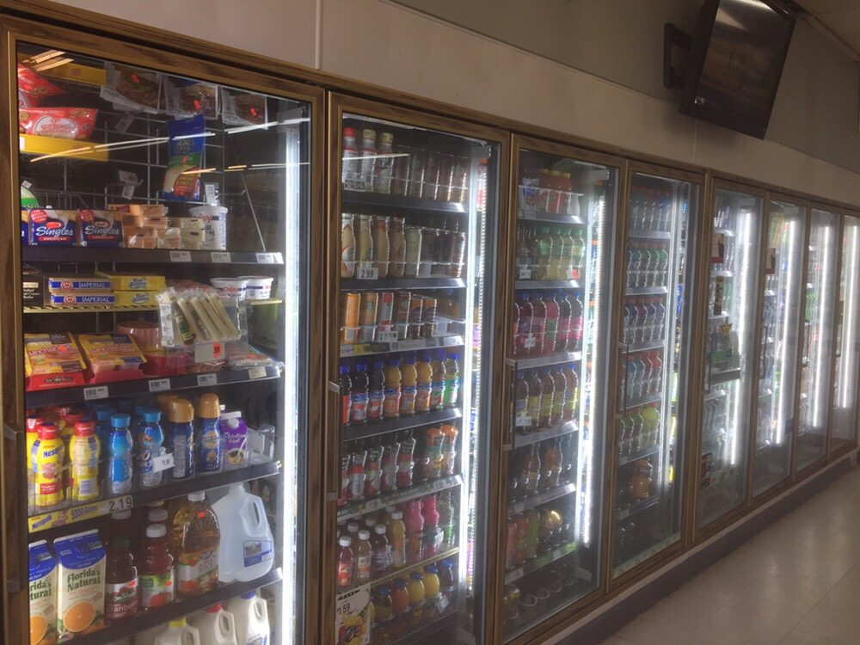](https://s3-media3.fl.yelpcdn.com/bphoto/eWhX5Q7HE9m7yV-7EHv0pg/o.jpg)

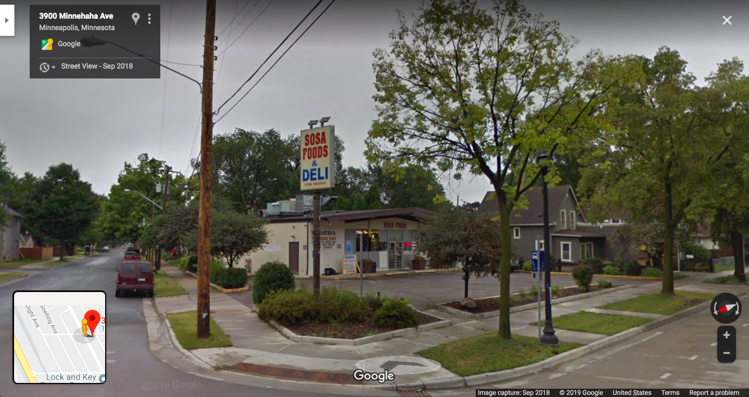

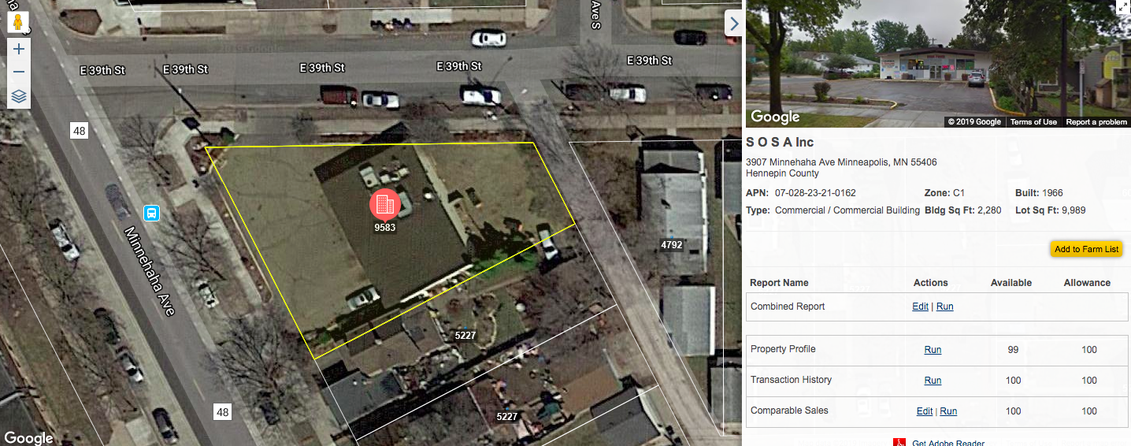

**SOSA KITCHEN EQUIPMENT LIST**

**1 Twelve foot Exhaust Hood with Make-Up Air Unit**

**2 Imperial Deep Fryers**

**1 Kronomatic Gyro Rotiserie**

**1 Tri-Star Combination Oven, Stove and Flat Top Grill**

**1 Electrolux Stove Top**

**1 Walk-In Cooler 20 feet long X 8 feet wide with 8 doors**

**1 Three Compartment Sink**

**1 Two Compartment Sink**

**1 Floor Mounted Mop Sink**

**1 Floor Scrubber Machine**

**2 Cash Registers**

**1 Security System with 8 Cameras and 1 Monitor**

**1 Coffee Maker**