Hillsborough County Municode for LDC Zoning (Lutz Downtown Center)

Note: Lower intensity Professional office and limited specialty retail uses (and single family residential allowed) Medical use prohibited.

Sec. 3.09.11. - Lutz Downtown Center Zoning District.
A.
Generally
The intent of the Lutz Downtown Center Zoning District (LDCZD) is to plan for an activity center that encourages a mixture of residential and lower intensity professional office, personal service and specialty retail uses in an area containing existing residential uses and buildings. Adoption of the LDCZD will assist in implementing the Comprehensive Plan.
B.
Affected Properties
1.
The use of the Lutz Downtown Center Zoning District shall be restricted to properties located in Figure 3.36.
C.
Permitted Uses
1.
Uses permitted in the Lutz Downtown Center Zoning District shall be limited to the following:
a.
Professional services,
b.
Florist/card shop,
c.
Beauty/barber shop,
d.
Locksmith;
e.
Watch, clock and jewelry sales and service,
f.
Photography studio,
g.
Tailor/seamstress,
h.
Art gallery/studio,
i.
Antiques shops (indoor sales),
j.
Educational materials sales (books, art supplies, music supplies, and similar educational materials),
k.
Newsstand,
l.
Novelty/souvenir shop,
m.
Single-family conventional residential,
n.
Bicycle repair service,
o.
Computer repair service,
p.
Shoe repair service, and
q.
Uses allowed in the RSC-6 zoning district.
2.
Retail uses shall be restricted to only those specified above.
3.
Health services and health practitioners are prohibited.
D.
Development Standards
1.
If a site is newly developed for non-residential uses or if an existing structure is expanded for non-residential uses, all B-PO zoning district requirements shall apply, with the following exceptions:
a.
The maximum height requirement shall be 35 feet.
b.
Maximum square footage per building shall be 6,000 square feet.
2.
It is the intent of the district to allow for the continued use of residential uses as well as the conversion of existing dwelling units, in whole or in part, to non-residential uses allowed within the zoning district. Area, height, bulk and placement regulations for residential uses shall be those of the RSC-6 residential zoning district. If a property owner desires to convert an existing dwelling unit with no expansion to a use permitted by 3.09.11.C, the following conditions shall apply:
a.
Area, height, bulk, and placement regulations of the RSC-6 residential zoning district shall apply.
b.
Parking space requirements for allowable nonresidential uses may be reduced to 50 percent of the requirement for the proposed use as listed in Part 6.05.00 of this Code. Turf block material may be used in lieu of pavement if approved by applicable agencies.
c.
Disabled parking spaces shall be provided pursuant to Part 6.05.02.J. of this Code.
d.
Parking spaces located in garages may be counted toward the parking requirement.
e.
Use of existing septic systems shall be regulated by Part 4.02.04 of this Code and Hillsborough County Ordinance 00-4, Utilities Connection Regulation, and any future amendments to this ordinance.
f.
Screening meeting the standards of Section 6.06.06.C.3 ("A" screening) of this Code shall be required along boundaries abutting adjacent properties containing active residential uses or residentially zoned properties.
g.
Dwelling units converted to non-residential uses shall conform to all applicable building code requirements.
3.
Whenever a mixture of residential and nonresidential uses is proposed in a single structure, the following additional standards shall apply:
a.
Non-residential uses may utilize all or part of the building/dwelling unit on a site. Mixed uses (residential and non-residential) shall not be freestanding (the residential and non-residential uses shall be contained within the same building/dwelling unit).
b.
No residential or non-residential uses shall be conducted in any accessory building.
c.
A maximum lot size of one acre shall apply.
d.
The maximum square feet of non-residential uses permitted on site shall be linked to the existing footprint of the residence.
e.
The appearance of the building/dwelling unit shall be clearly residential in nature. No commercial display windows or storefront type of building shall be permitted. No outside display, storage, or use of land is permitted.
E.
Specific Standards for Non-Residential Uses
1.
Hours of operation shall be limited from 6:00 A.M. to 9:00 P.M.
2.
No activities associated with the operations of a business, other than grounds maintenance, shall be permitted in required yards adjacent to residential uses or residentially zoned lots.
3.
Outside lighting shall be restricted to motion-activated security lighting. Full-Cutoff Light fixtures shall be used and shall project a maximum of 0.20 foot candles at the zoning lot line.
4.
For any new construction, no customer entrances shall be permitted onto yards abutting residential lots. For any new construction, buildings shall be oriented toward the roadway.
5.
Yards abutting residential lots shall be screened according to Section 6.06.06.C.3 ("A" screening).
6.
Dumpsters shall be fully enclosed according to Section 6.06.06.C.3 ("A" screening).
F.
Roadway Aesthetics
1.
All trees not located within the existing or future right-of-way and recognized as a protected species under the provisions of this Code with a diameter at breast height (DBH) of five inches or greater shall be preserved within 25 feet of property boundaries abutting rights-of-way. Trees within this area classified to be a hazard as determined by a Certified Arborist, a Registered Consulting Arborist or other qualified plantsman are not required for preservation. Appropriate permitting as specified in Section 4.01.03 of this Code, however, shall be required. The administrator shall have the discretion to approve the removal of trees that conflict with the development of vehicular access and disabled parking.
2.
Signage shall be as provided in this Code except as follows.
a.
Pole signs shall be prohibited. Ground signs shall be limited to Monument Signs. Billboards, pennants and banners shall be prohibited.
b.
Only one wall sign shall be permitted on the front façade of the building. The wall sign should not project outward from the wall to which it is attached more than six inches.
c.
Signs shall be made of natural wood material, painted wood, or synthetic material with a natural wood appearance. No plywood, wallboard, particle board, or similar materials shall be used for signage.
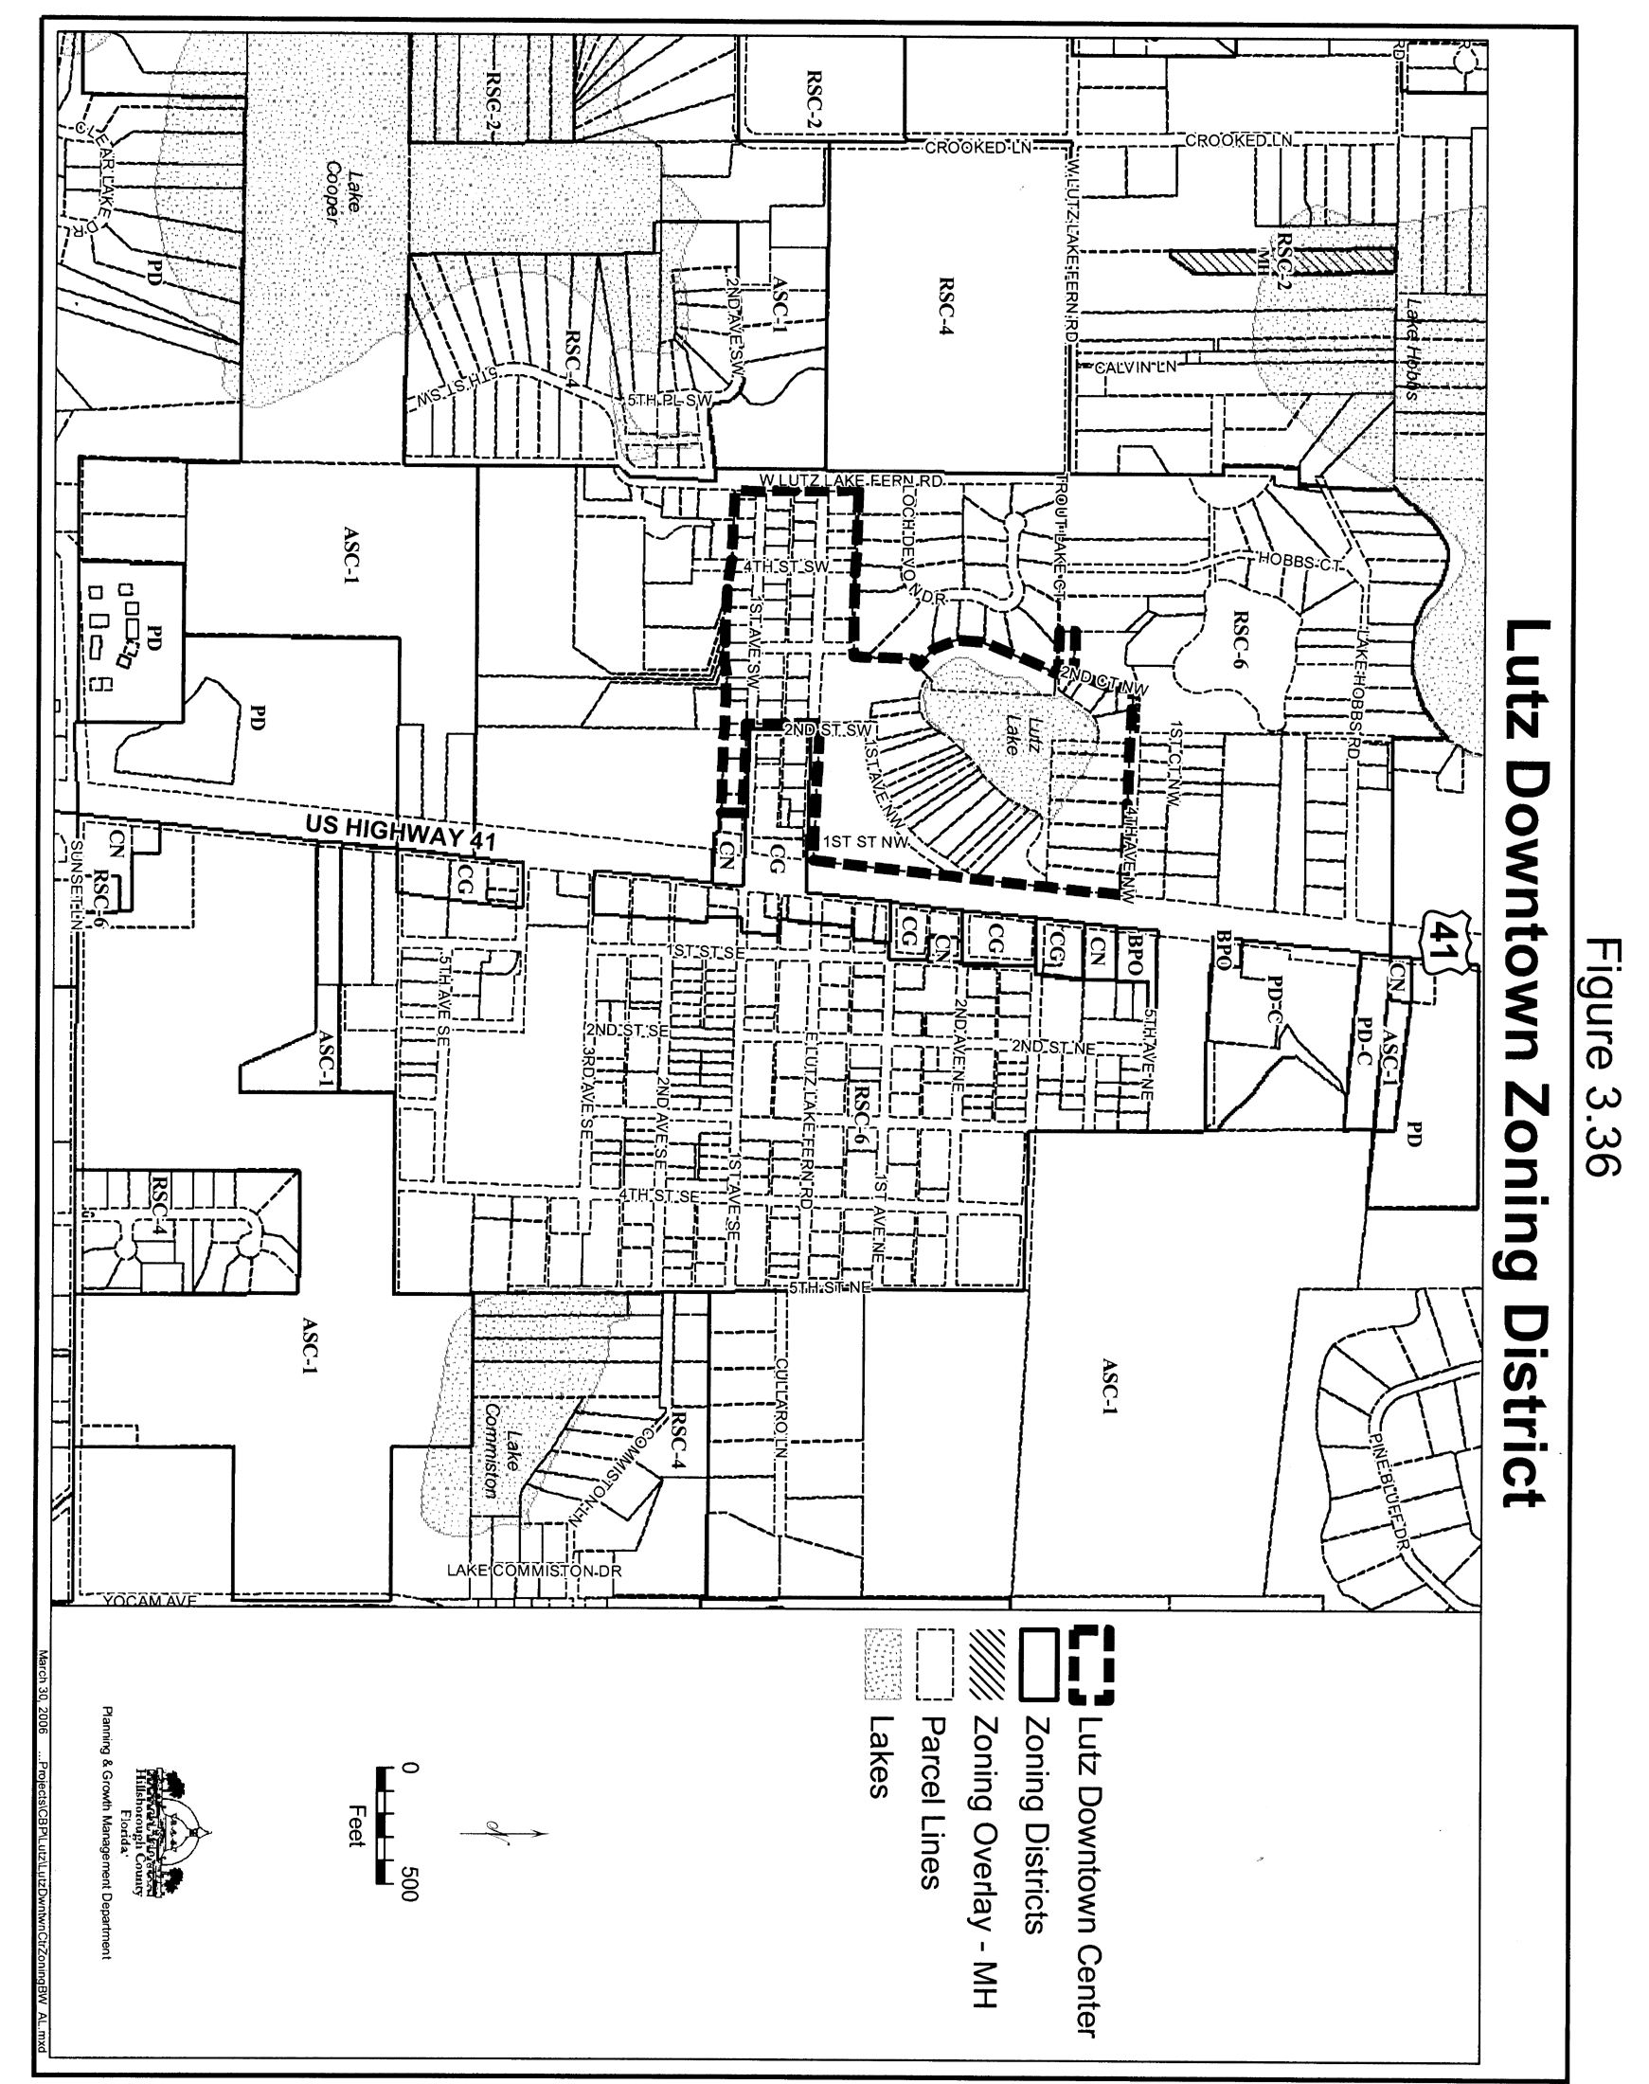
Figure 3.36

